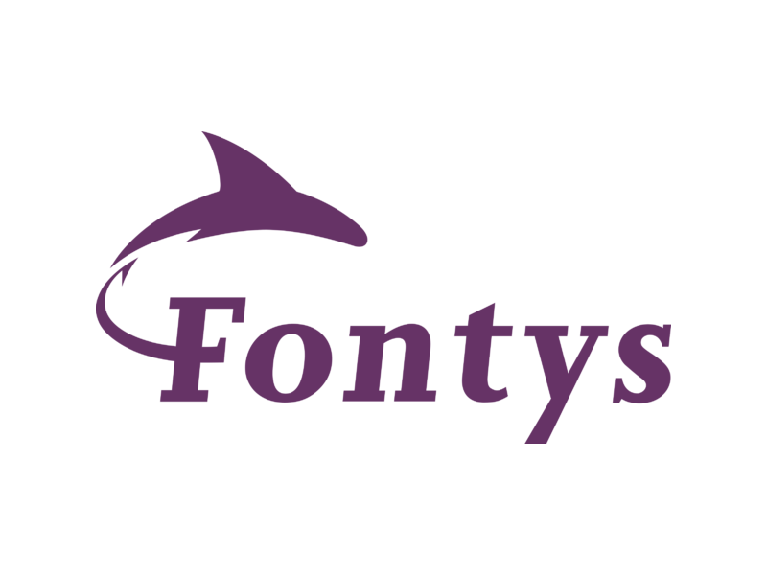

**Test Report**

**Individual Project: Stream Sage**

**Date:** 13-06-2024  
**Developer:** Georgi Tinchev (g.tinchev@student.fontys.nl)  
**Tutor:** Bhardwaj Sachin (sachin.bhardwaj@fontys.nl)

**Table of Contents**

* Test Cases + Test Results
* Recommendations for System Improvement

**Test Cases + Test Results**

**Movie Management (FRD-1)**

1. **Add Movie**
   * **ID:** TC-MOV-01
   * **Functional Requirement ID:** FRD-1
   * **Pre-condition:** Administrator is logged in.
   * **Test Steps:**
     + Navigate to the "Add Movie" section of the admin dashboard.
     + Enter all required movie details (title, release date, description, poster image URL, trailer URL, runtime, average rating).
     + Click on the "Add Movie" button.
   * **Expected Result:** The movie should be successfully added to the database.

**Result:** The movie was added successfully without errors. Test case passed.

1. **Edit Movie**
   * **ID:** TC-MOV-02
   * **Functional Requirement ID:** FRD-1
   * **Pre-condition:** Administrator is logged in.
   * **Test Steps:**
     + Navigate to the "Edit Movie" section of the admin dashboard.
     + Select an existing movie from the list.
     + Modify one or more details (title, description, runtime).
     + Save the changes.
   * **Expected Result:** The movie details should be updated in the database.

**Result:** The movie details were updated as expected. Test case passed.

1. **Delete Movie**
   * **ID:** TC-MOV-03
   * **Functional Requirement ID:** FRD-1
   * **Pre-condition:** Administrator is logged in.
   * **Test Steps:**
     + Navigate to the "Delete Movie" section of the admin dashboard.
     + Select a movie to delete from the list.
     + Confirm the deletion action.
   * **Expected Result:** The selected movie should be permanently removed from the database.

**Result:** The movie was successfully deleted from the database. Test case passed.

**User Management (FRD-2)**

1. **User Registration**
   * **ID:** TC-USER-01
   * **Functional Requirement ID:** FRD-2
   * **Pre-condition:** User attempts to register.
   * **Test Steps:**
     + Navigate to the registration page.
     + Fill out the registration form with valid details (username, email, password).
     + Submit the registration form.
   * **Expected Result:** The user should be registered and able to log in with the provided credentials.

**Result:** Registration was successful. User can now log in. Test case passed.

1. **User Login**
   * **ID:** TC-USER-02
   * **Functional Requirement ID:** FRD-2
   * **Pre-condition:** User attempts to log in.
   * **Test Steps:**
     + Navigate to the login page.
     + Enter valid user credentials (username/email and password).
     + Click on the "Login" button.
   * **Expected Result:** The user should be authenticated and logged into the system.

**Result:** Login successful. User authenticated without issues. Test case passed.

1. **Update User Profile**
   * **ID:** TC-USER-03
   * **Functional Requirement ID:** FRD-2
   * **Pre-condition:** User is logged in.
   * **Test Steps:**
     + Navigate to the user profile section.
     + Modify user profile information (e.g., update email address or change password).
     + Save the changes.
   * **Expected Result:** User profile should be updated with the new information.

**Result:** User profile updated successfully. Changes reflected in the system. Test case passed.

**Genre, Actor, Director Management (FRD-3)**

1. **Add Genre**
   * **ID:** TC-GENRE-01
   * **Functional Requirement ID:** FRD-3
   * **Pre-condition:** Administrator is logged in.
   * **Test Steps:**
     + Navigate to the "Add Genre" section of the admin dashboard.
     + Enter genre details (name and description).
     + Click on the "Add Genre" button.
   * **Expected Result:** The new genre should be added to the genre list.

**Result:** Genre added successfully. Test case passed.

1. **Edit Genre**
   * **ID:** TC-GENRE-02
   * **Functional Requirement ID:** FRD-3
   * **Pre-condition:** Administrator is logged in.
   * **Test Steps:**
     + Navigate to the "Edit Genre" section of the admin dashboard.
     + Select a genre from the list to edit.
     + Modify the genre details, such as updating the description.
     + Save the changes.
   * **Expected Result:** The genre details should be updated in the system.

**Result:** Genre edited successfully. Changes saved correctly. Test case passed.

1. **Delete Genre**
   * **ID:** TC-GENRE-03
   * **Functional Requirement ID:** FRD-3
   * **Pre-condition:** Administrator is logged in.
   * **Test Steps:**
     + Navigate to the "Delete Genre" section of the admin dashboard.
     + Select a genre from the list to delete.
     + Confirm the deletion action.
   * **Expected Result:** The selected genre should be removed from the genre list.

**Result:** Genre deleted successfully. Test case passed.

1. **Add Actor**
   * **ID:** TC-ACTOR-01
   * **Functional Requirement ID:** FRD-3
   * **Pre-condition:** Administrator is logged in.
   * **Test Steps:**
     + Navigate to the "Add Actor" section of the admin dashboard.
     + Enter actor details (name).
     + Click on the "Add Actor" button.
   * **Expected Result:** The new actor should be successfully added to the actor database.

**Result:** Actor added successfully. Test case passed.

1. **Edit Actor**
   * **ID:** TC-ACTOR-02
   * **Functional Requirement ID:** FRD-3
   * **Pre-condition:** Administrator is logged in.
   * **Test Steps:**
     + Navigate to the "Edit Actor" section of the admin dashboard.
     + Select an actor from the list to edit.
     + Modify actor details, such as updating bio or image.
     + Save the changes.
   * **Expected Result:** Actor details should be updated with the new information.

**Result:** Actor edited successfully. Test case passed.

1. **Delete Actor**
   * **ID:** TC-ACTOR-03
   * **Functional Requirement ID:** FRD-3
   * **Pre-condition:** Administrator is logged in.
   * **Test Steps:**
     + Navigate to the "Delete Actor" section of the admin dashboard.
     + Select an actor from the list to delete.
     + Confirm the deletion action.
   * **Expected Result:** The selected actor should be permanently deleted from the actor database.

**Result:** Actor deleted successfully. Test case passed.

1. **Add Director**
   * **ID:** TC-DIRECTOR-01
   * **Functional Requirement ID:** FRD-3
   * **Pre-condition:** Administrator is logged in.
   * **Test Steps:**
     + Navigate to the "Add Director" section of the admin dashboard.
     + Enter director details (name, bio, image).
     + Click on the "Add Director" button.
   * **Expected Result:** The new director should be added to the director list.

**Result:** Director added successfully. Test case passed.

1. **Edit Director**
   * **ID:** TC-DIRECTOR-02
   * **Functional Requirement ID:** FRD-3
   * **Pre-condition:** Administrator is logged in.
   * **Test Steps:**
     + Navigate to the "Edit Director" section of the admin dashboard.
     + Select a director from the list to edit.
     + Modify director details, such as updating bio or image.
     + Save the changes.
   * **Expected Result:** Director details should be updated in the system.

**Result:** Director edited successfully. Test case passed.

1. **Delete Director**
   * **ID:** TC-DIRECTOR-03
   * **Functional Requirement ID:** FRD-3
   * **Pre-condition:** Administrator is logged in.
   * **Test Steps:**
     + Navigate to the "Delete Director" section of the admin dashboard.
     + Select a director from the list to delete.
     + Confirm the deletion action.
   * **Expected Result:** The selected director should be removed from the director list.

**Result:** Director deleted successfully. Test case passed.

**User Authentication (FRD-4)**

1. **User Authentication**
   * **ID:** TC-AUTH-01
   * **Functional Requirement ID:** FRD-4
   * **Pre-condition:** User attempts to log in.
   * **Test Steps:**
     + Navigate to the login page.
     + Enter valid user credentials (username/email and password).
     + Click on the "Login" button.
   * **Expected Result:** The user should be authenticated and logged into the system.

**Result:** User authenticated successfully. Test case passed.

**Interpretation Management (FRD-5)**

1. **Submit Interpretation**
   * **ID:** TC-INTERP-01
   * **Functional Requirement ID:** FRD-5
   * **Pre-condition:** User is logged in.
   * **Test Steps:**
     + Navigate to the "Submit Interpretation" section.
     + Enter interpretation content (text) and select the associated movie.
     + Click on the "Submit" button.
   * **Expected Result:** The interpretation should be successfully submitted and visible on the movie's page.

**Result:** Interpretation submitted successfully. Test case passed.

**Review Management (FRD-6)**

1. **Submit Review**
   * **ID:** TC-REVIEW-01
   * **Functional Requirement ID:** FRD-6
   * **Pre-condition:** User is logged in.
   * **Test Steps:**
     + Navigate to the "Submit Review" section.
     + Enter review content (rating, text) and select the associated movie.
     + Click on the "Submit" button.
   * **Expected Result:** The review should be successfully submitted and visible on the movie's page.

**Result:** Review submitted successfully. Test case passed.

**Recommendations for System Improvement**

1. **Enhanced Error Handling**
   * Implement more robust error handling mechanisms throughout the application to provide meaningful error messages to users and administrators.
2. **Performance Optimization**
   * Conduct performance profiling and optimization because some of the queries and or different forms take a while to load up.
3. **Accessibility**
   * Ensure the application meets accessibility standards (e.g., WCAG) to accommodate users with disabilities.
4. **Security Enhancements**
   * Regularly review and update data, and ensure proper encapsulation is met all across the application.
5. **User Interface Refinements**
   * Improve user interface design for better usability and intuitive navigation, especially for non-technical users.